**Practical 3**

**Name:** Ishaan Bose

**Reg. no.:** 2147116

**1. Describe Load Balancing and its significance in Cloud Environment.**

Cloud load balancing is defined as the method of splitting workloads and computing properties in a cloud computing. It enables enterprise to manage workload demands or application demands by distributing resources among numerous computers, networks or servers. Cloud load balancing includes holding the circulation of workload traffic and demands that exist over the Internet. Cloud load balancing helps enterprises achieve high performance levels for potentially lower costs than traditional on-premises load balancing technology. Cloud load balancing takes advantage of the cloud's scalability and agility to meet the demands of distributed workloads with high numbers of client connections. It also improves overall availability, increases throughput and reduces latency.

Cloud load balancing takes a software-based approach to distributing network traffic across resources, as opposed to hardware-based load balancing, which is more common in enterprise data centres. A load balancer receives incoming traffic and routes those requests to active targets based on a configured policy. A load balancing service also monitors the health of the individual targets to ensure that those resources are fully operational.

**2. List the Load Balancing Service available in AWS, Azure and GCP.**

* Amazon Web Services (AWS) **Elastic Load Balancing** distributes incoming client traffic and routes it to registered targets such as EC2 instances. Elastic Load balancing supports four types of load balancers: Application, Network, Gateway and Classic. The load balancers differ in the features offered, the network layers at which they operate and supported communication protocols.
* **Google Cloud Load Balancer** (GCLB) service available on Google Cloud Platform is built on the same front-end server infrastructure that powers Google. The service offers a range of load balancers that vary depending on whether the customer needs external or internal load balancing, global or regional load balancing, Premium or Standard network service tiers, proxy or pass-through services, among other factors.
* Microsoft Azure offers four load balancing services. **Azure Traffic Manager** is a (OSI model) layer 7 DNS-based traffic load balancer for delivering services across global Azure regions. **Azure Load Balancer** is a layer 4 network load balancer for routing traffic between VMs. **Azure Application Gateway** is a layer 7 delivery controller for regional applications. **Azure Front Door** is a highly secure, layer 7 global load balancer for microservice.

**3. Create 2 Identical AWS EC2 / GCP VM Instances (Instance Name: Regno_EC2_VM1, Regno_EC2_VM2) and install a webserver of your choice in each of the instances to host web site of your organization globally.**

1. Create a second ec2 instance with the name 2147116_EC2_VM2.

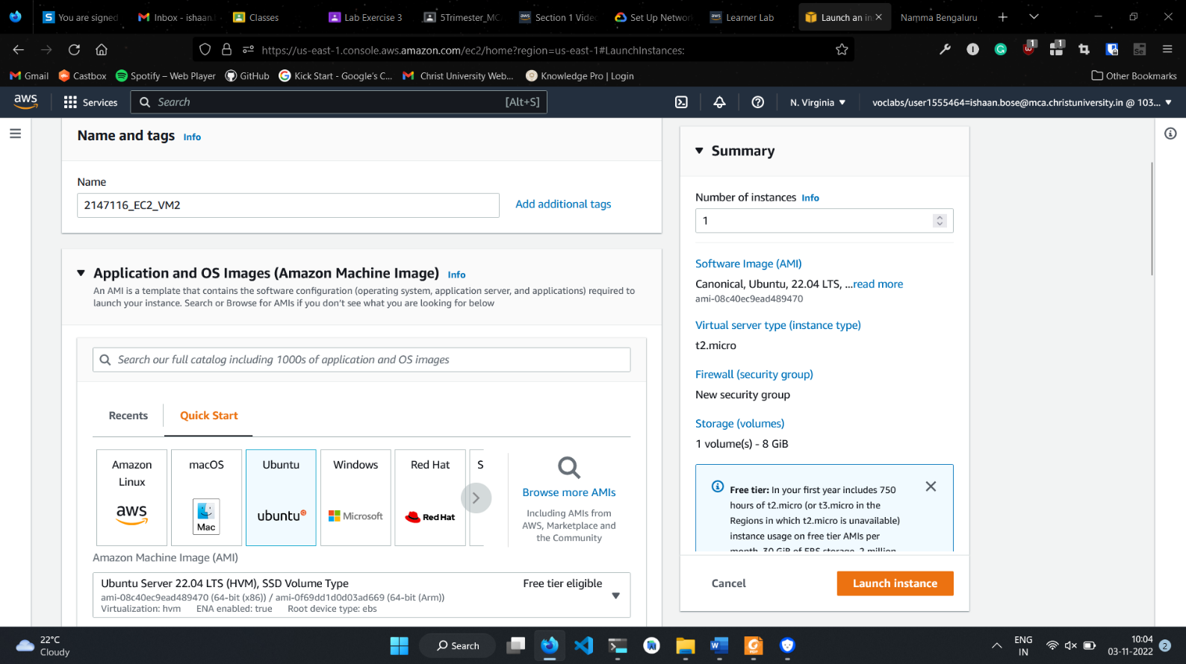

1. Select pre-existing key pair login and security group

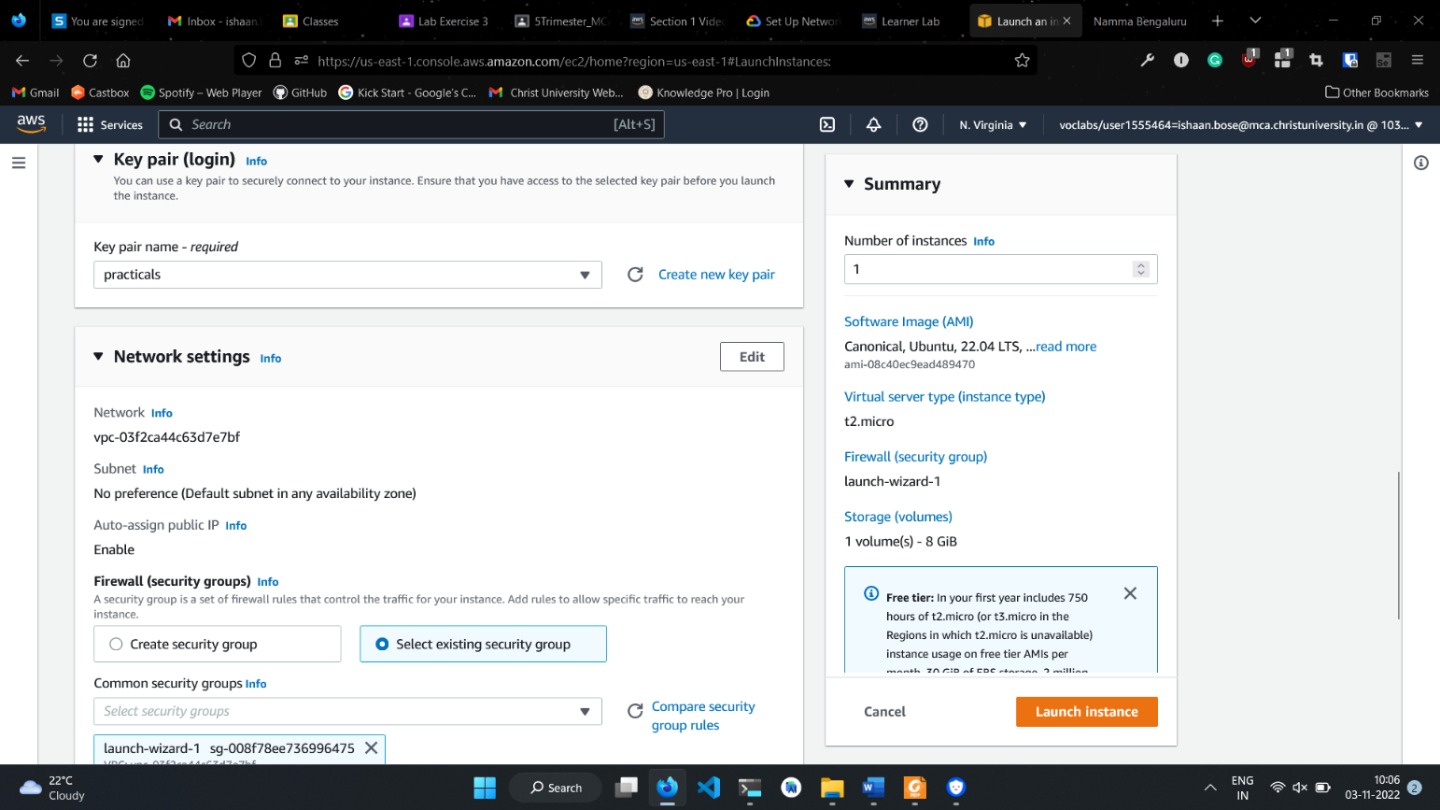

1. Finally, click on Launch Instances.
2. Go to all instances and install a web server on new instance.

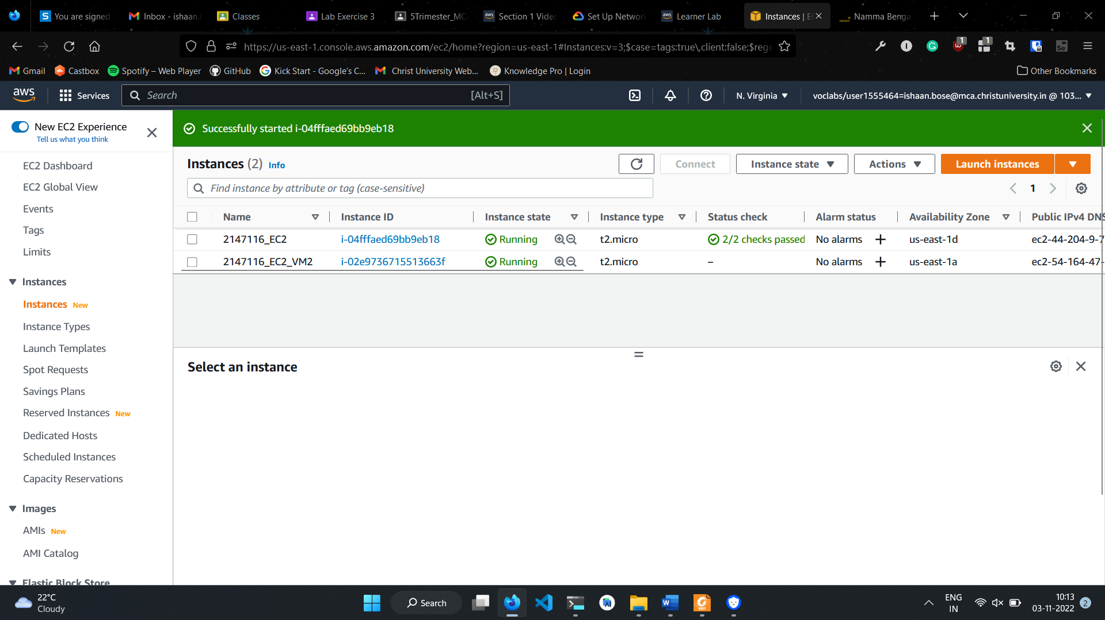

1. View website running on new instance.

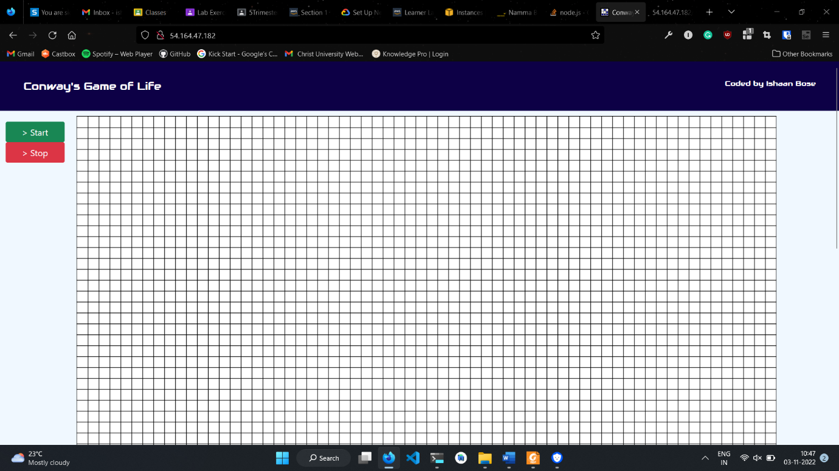

1. Go to Load Balancer navigation menu and click on Create Load Balancer.

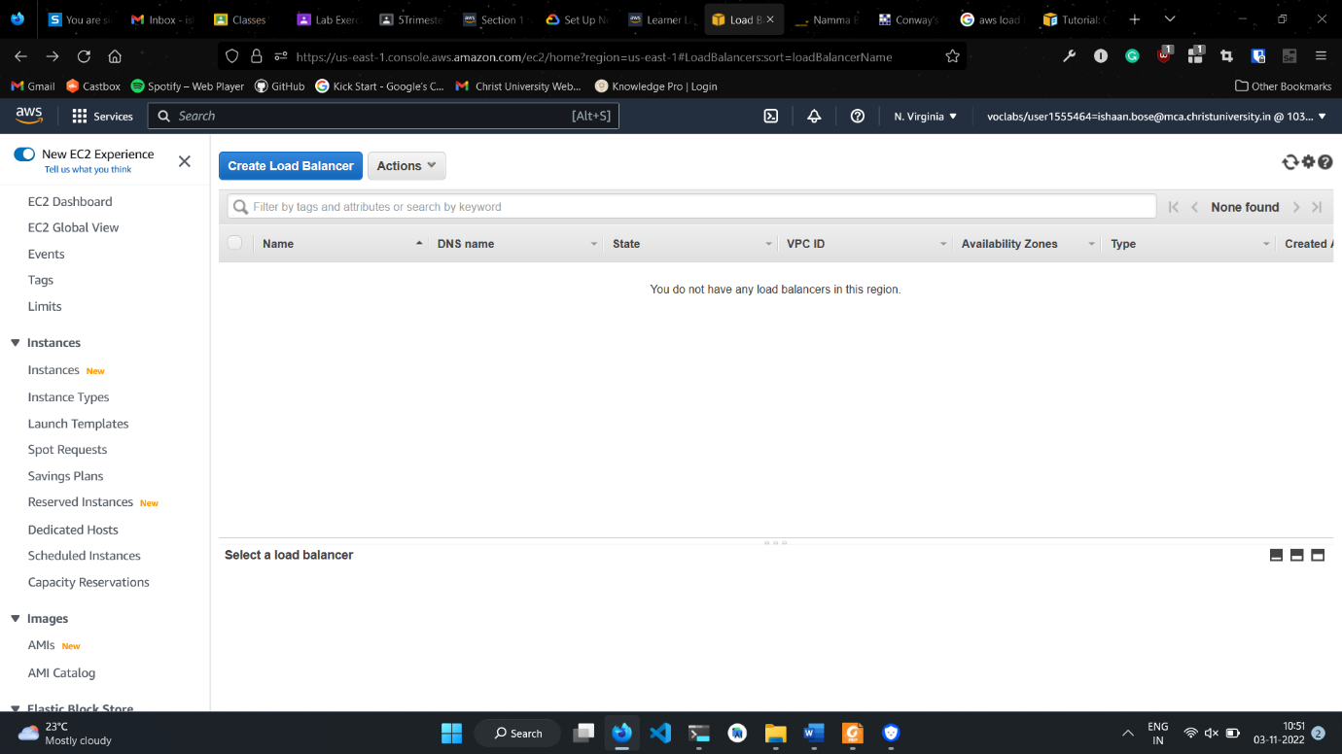

1. Scroll down to Classic Load Balancer and click create.

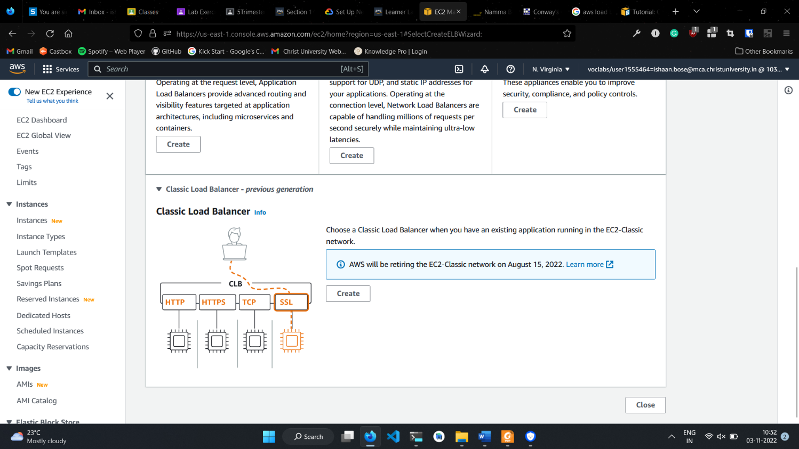

1. Fill in the details as follows:

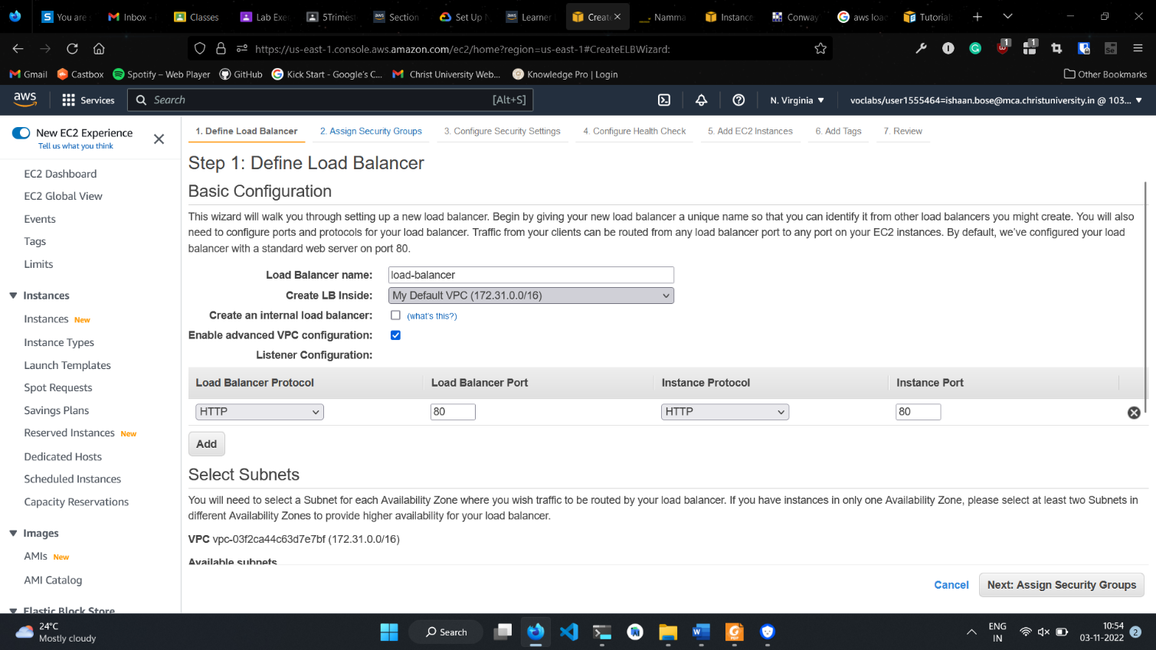

1. Select subnets as per your instances.

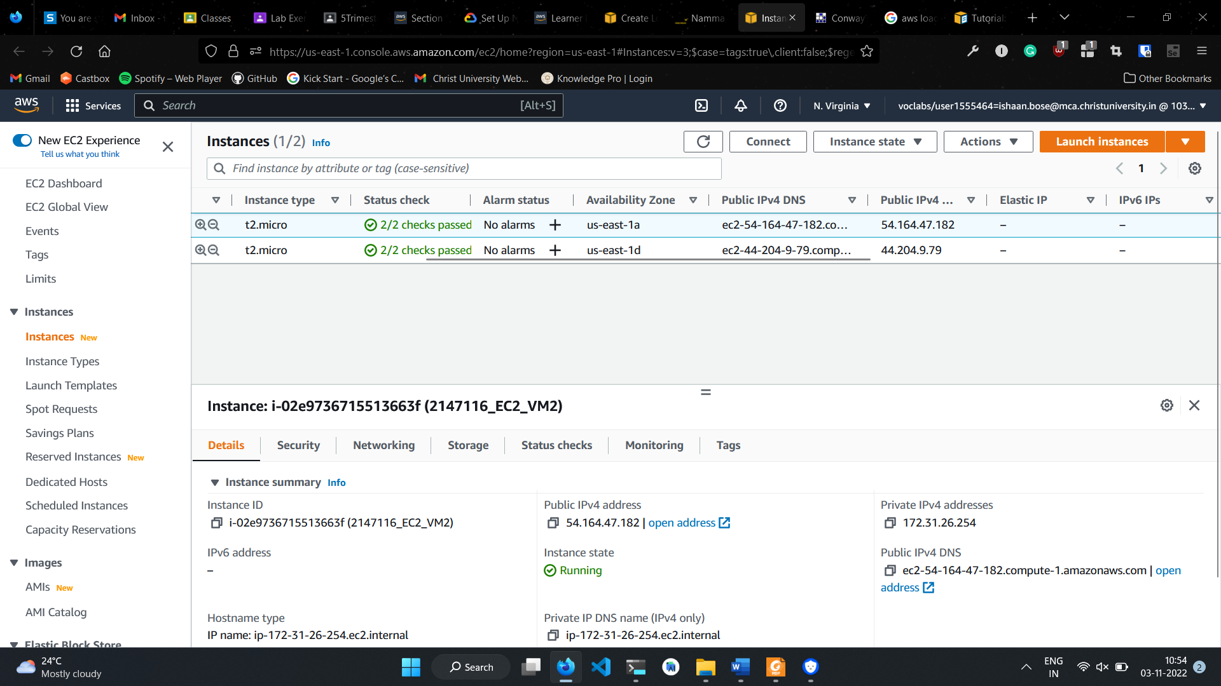

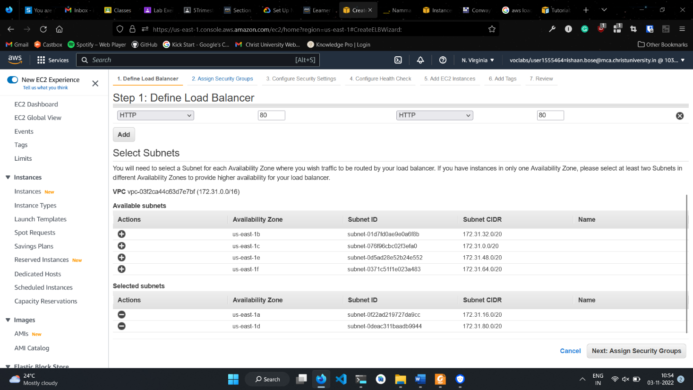

1. Click on Next: Assign Security Groups
2. Select the existing security group assigned to the instances.

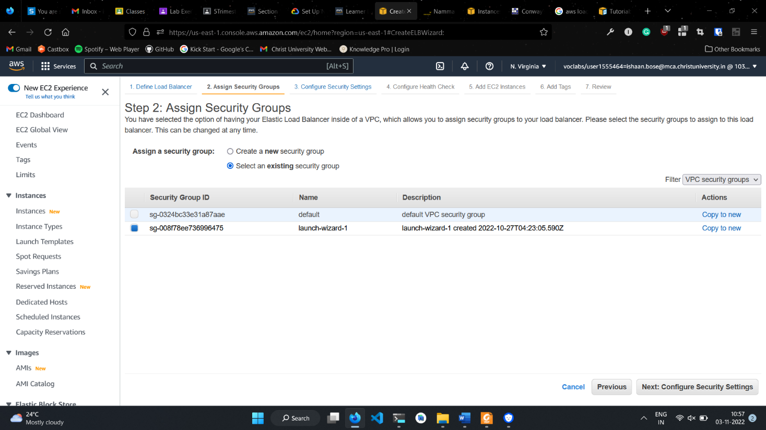

1. Click on Next: Configure Security Settings
2. For this practical, we are not using a secure listener. Choose Next: Configure Health Check to continue to the next step.
3. Change ping path to “/” and click on Next: Add EC2 Instances

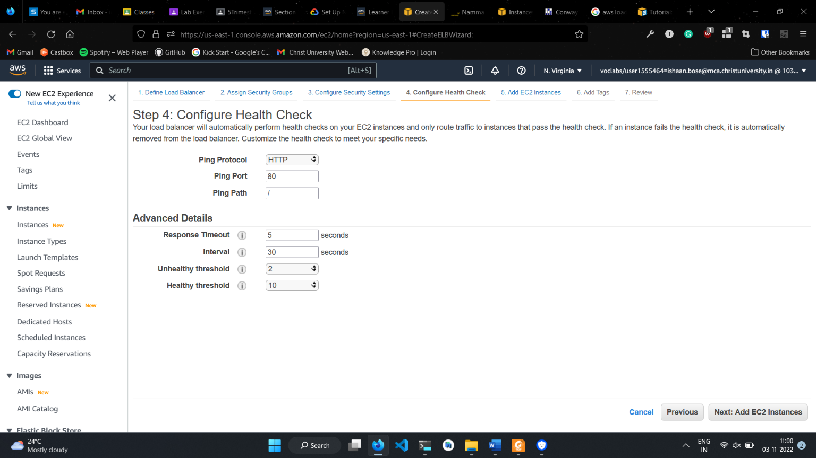

1. Add the instances you wish to load balance.
2. Click Next: Add Tags. This page is optional and can be skipped.
3. Click on Review and Create
4. Verify all details and click on Create.
5. After load balancer is created, click on close.

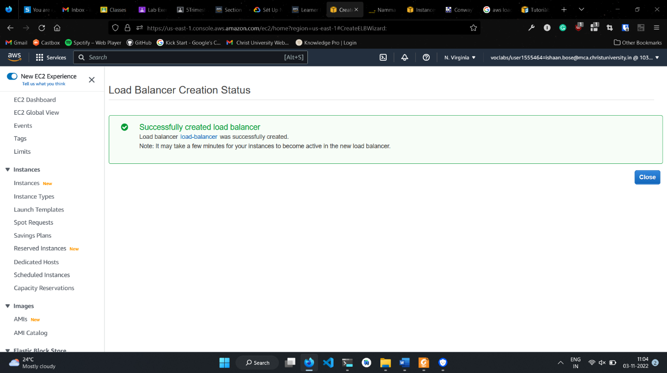

1. Wait for instances to be in service.

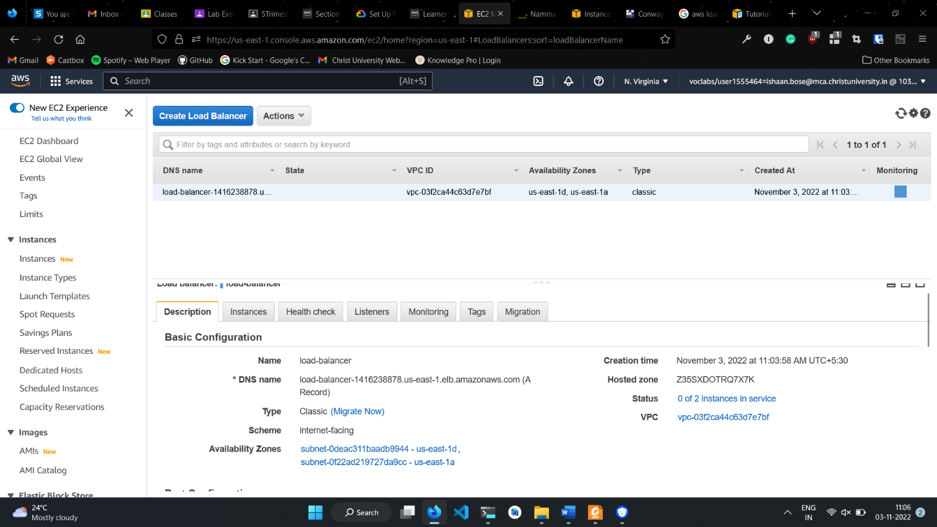

1. Once the instances are in service, copy the DNS name into address bar.
2. Refresh after a while to see both instances’ websites being displayed.

